**Data Set: Wine Reviews**

**Source:** Kaggle

**Link:** <https://www.kaggle.com/zynicide/wine-reviews>

**Tools used:** Tableau and R

This dataset provides great insights and is different than the kind of datasets I’ve worked with before. It was a good learning opportunity and so this was my main inspiration in choosing this dataset.

The Wine Reviews dataset has 13 columns and 130k records. The columns can be described as:

1. Country: The country that the wine is from.
2. Description: the review description.
3. Designation: The vineyard within the winery where the grapes that made the wine are from
4. Points: The number of points Wine Enthusiast/ Reviewer rated the wine on a scale of 1-100
5. Price: The cost for a bottle of the wine($)
6. Province: The province or state that the wine is from
7. Region_1: The wine growing area in a province or state
8. Region_2: Sometimes there are more specific regions specified within a wine growing area, but this value can sometimes be blank
9. Taster_name: Name of the reviewer.
10. Taster_twitter_handle: reviewer twitter handle
11. Title: The title of the wine review, which often contains the vintage if you're interested in extracting that feature
12. Variety: The type of grapes used to make the wine (ex. Pinot Noir)

13: Winery: The winery that made the wine

*In order to carry on my analysis I have added a few columns as derived/calculated attributes. These are explained in detail with their respective visualizations and analysis below.*

**Initial Questions?**

1. What is the relationship between the price of the wine to the points given to the wine?
2. What are the best wine options for customers on a low budget?
3. What is the country wise comparison of various wines based on the reviews?
4. Can the wines be classified as Red/ White/ Rose, in order to perform further analysis?
5. Which taster is comparatively active, how are the point margins given by them and the description lengths?
6. Can the wines be classified into the famous types?
7. Which are the best wineries?
8. Which are the most reviewed varieties?

**Data Insights and Visualizations:**

1. **The relationship between the price of the wine and the points given by the tasters, filtered by country:**

The graph below is filtered for Chile:

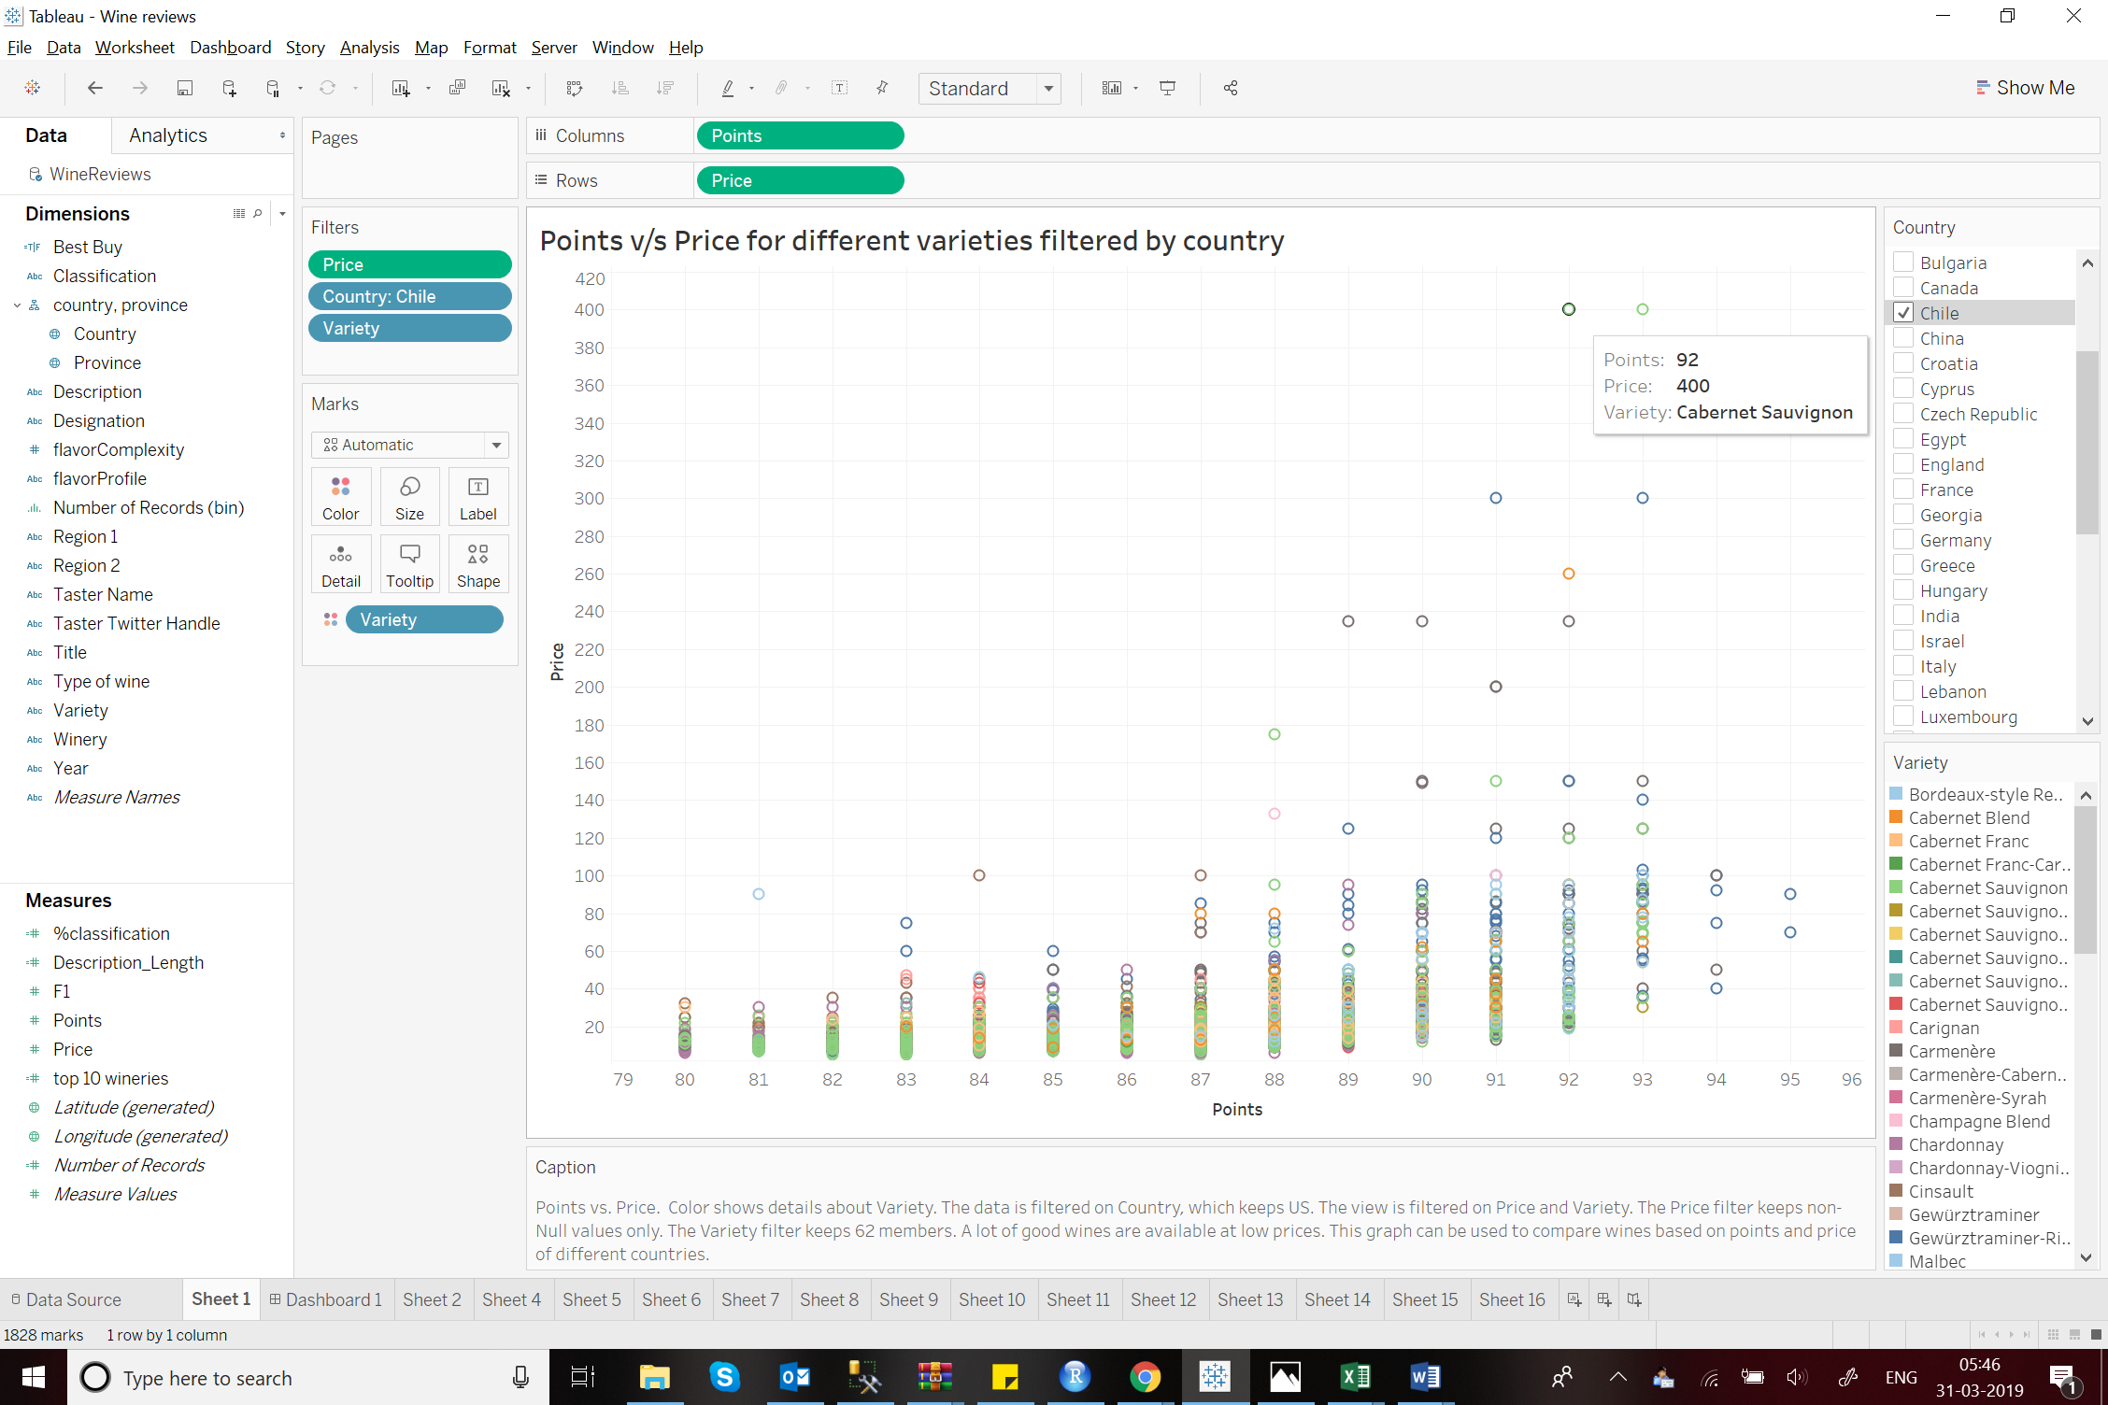

From the graph it is clear that there are a number of good wines( wines with higher points) available at lower prices. The wines having the maximum points are both below $100 for Chile. Most of the wines are priced under $80 with maximum variety density below $50. We can also see the point to price distribution for different countries to get an overall comparison.

In case of the US:

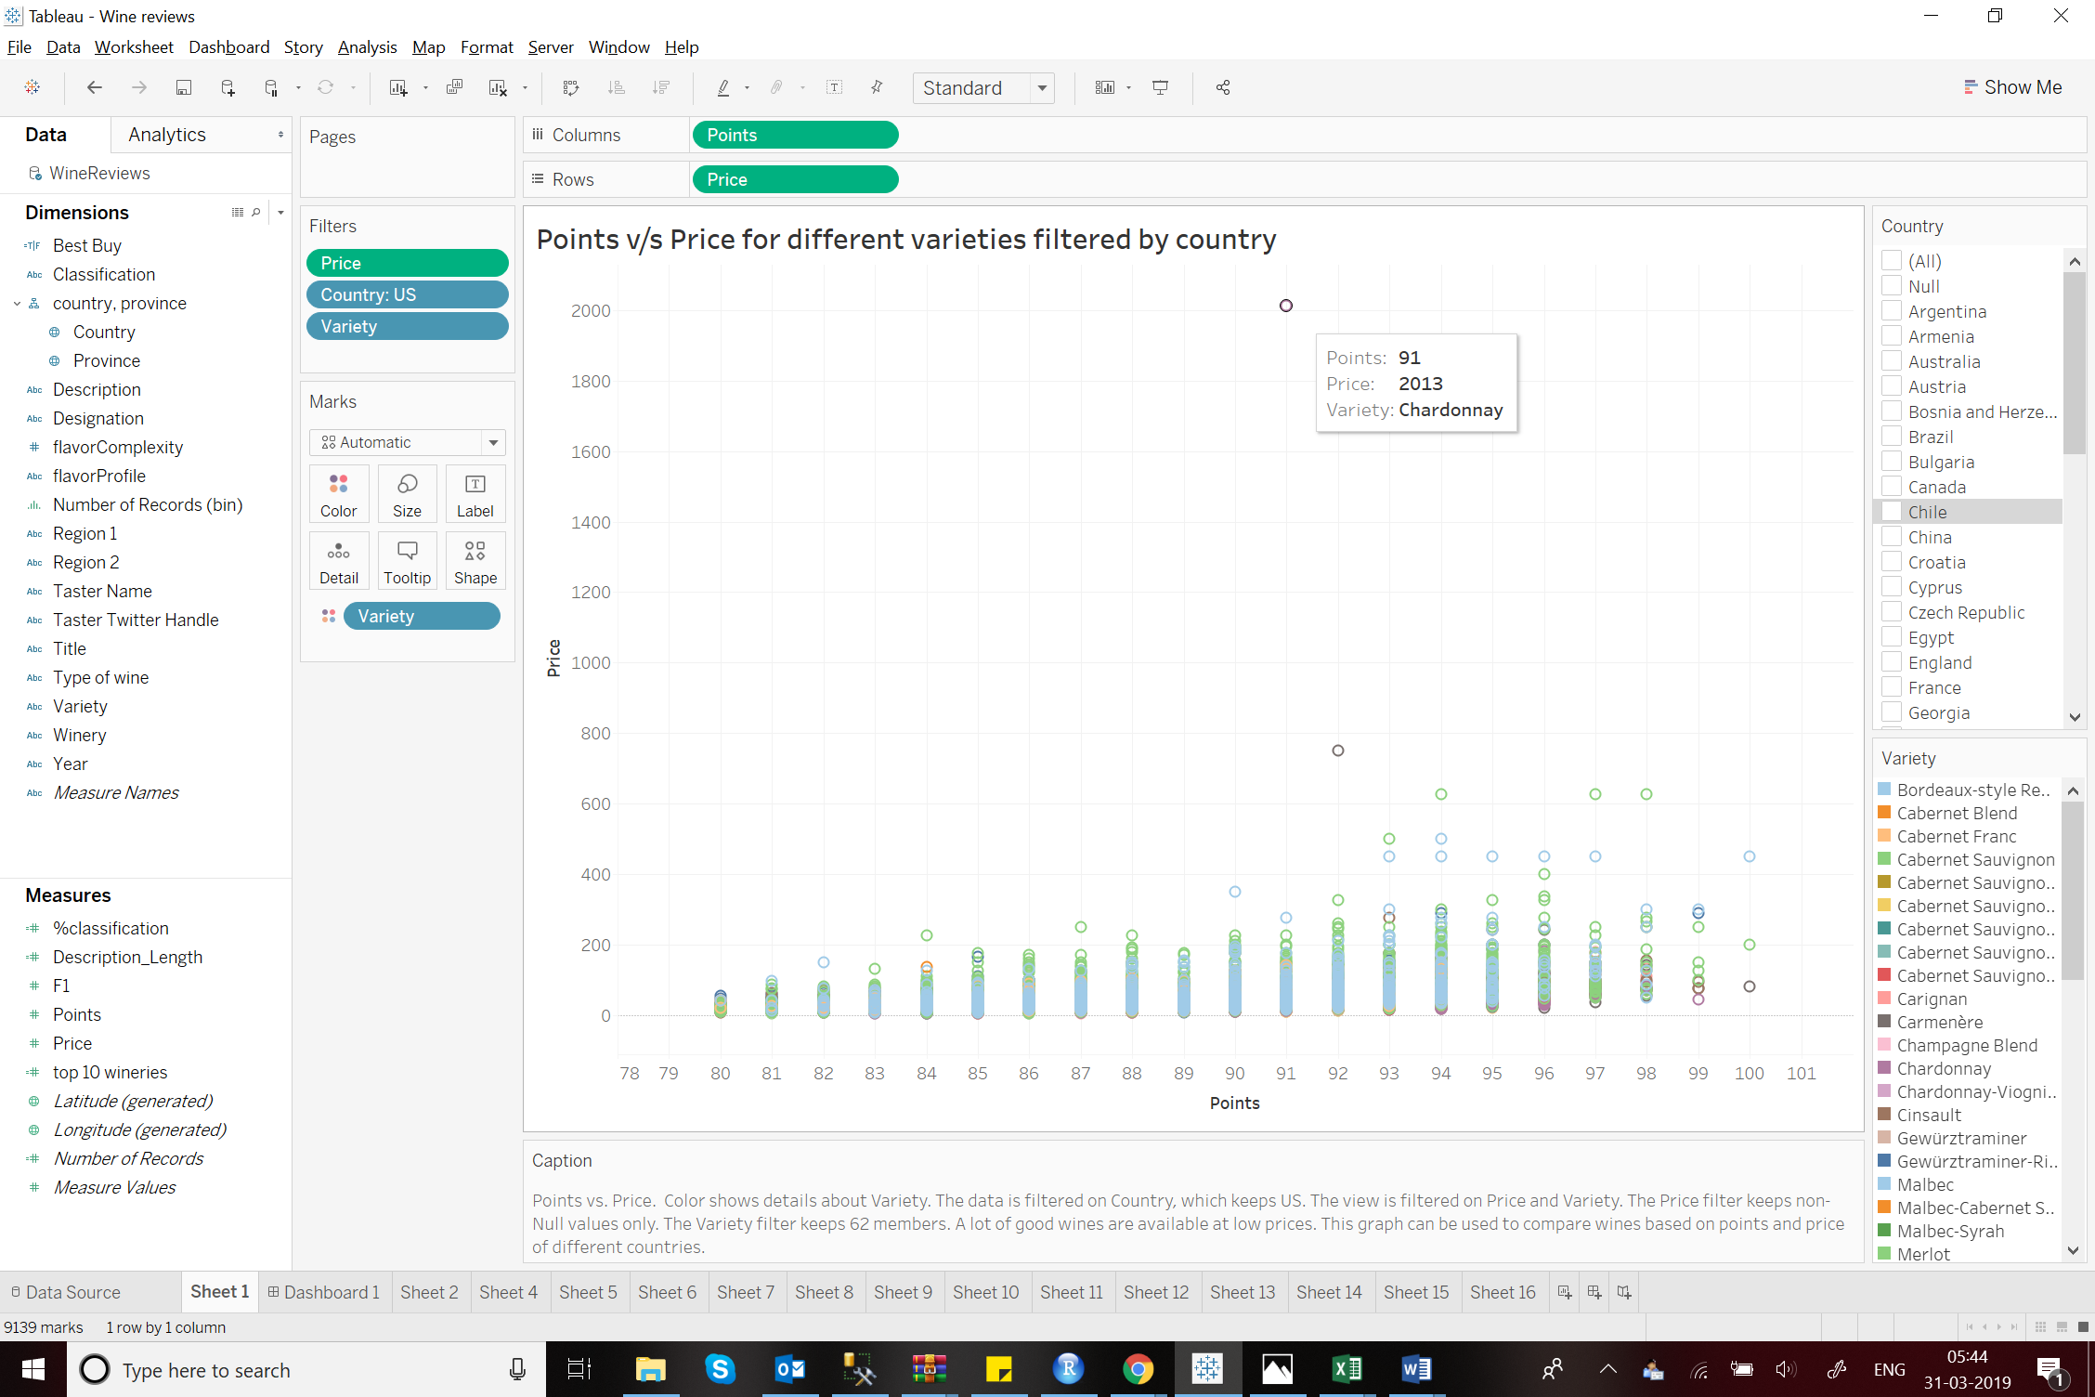

The number premium wines is higher in the US. However, the most expensive wine has not got the best reviewed points.

1. **Country wise Maximum points distribution along with the number of reviews:**

According to this map, countries like US, France, Portugal and Australia have gotten maximum of 100 on the review. This maps shows the maximum points received by wines of a particular country. However it also shows the number of reviews to get a better judgement of comparison.

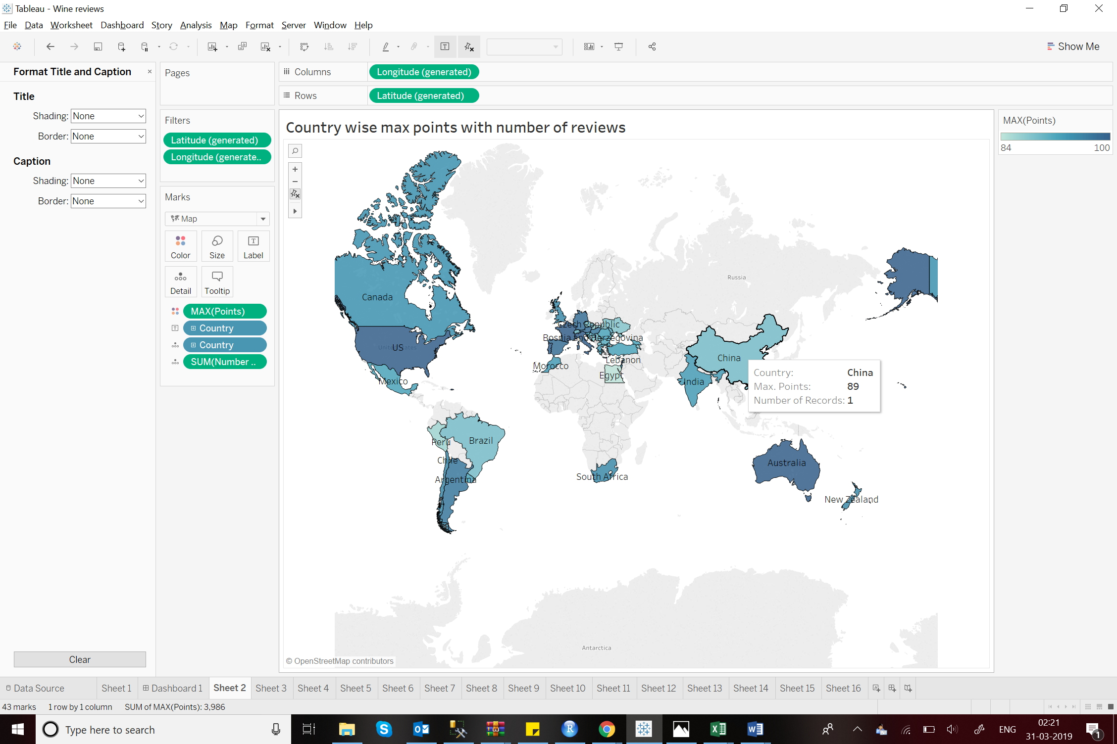

1. **Best Buy Wines( under $50 having more than 90 points) filtered by countries(including province):**

This stacked bar plot shows the number of wines that are classified as best buy. For this I have created a calculated field, Best_Buy, that selects the wines that are under $50 and received more than 90 points. The plot clearly shows that the number of these wine selections for US is the highest followed by France and Italy. The chart also shows the provinces with maximum such options.

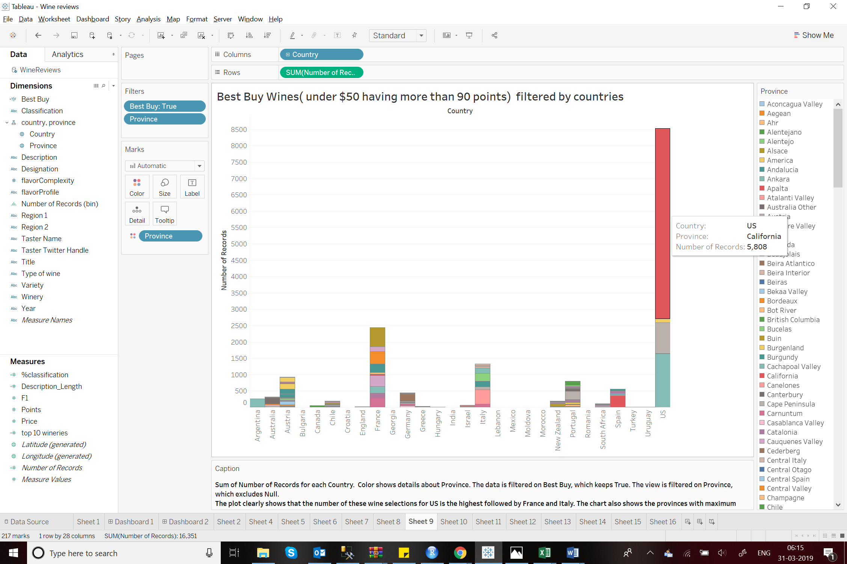

Since the US has the maximum number of best buy wines, the bubble chart below shows the varieties of these wines in the different provinces. The province of California has the maximum number of wines of varieties like Pinot Noir, Chardonnay etc.

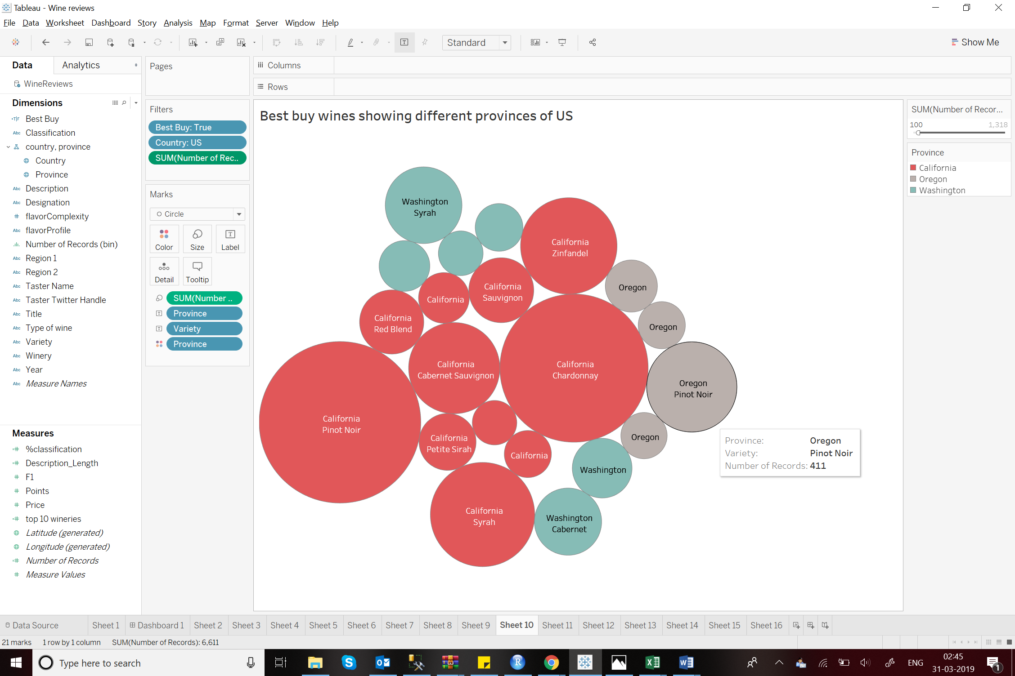

1. **Wine Classification:**

**Data Preparation and Calculation**

Based on the description, I wanted to classify the wines as Red/White/Rose. For this I created an additional column of **Classification** which identifies the records for Red, White or Rose wine.

I wanted to further classify the records into 8 most popular types of wines. To achieve this I created another column namely **Type of wine** which classifies the records under Riesling, Cabernet Sauvignon, Sauvignon Blanc, Chardonnay, Syrah, Pinot Noir, Zinfandel and Pinot Gris.

**Visualisation:**

**4.1 Number of most common wine types:**

The pie chart below shows the number of wines classified under the common types. Maximum being Cabernet Sauvignon and minimum wines being Pinot Gris.

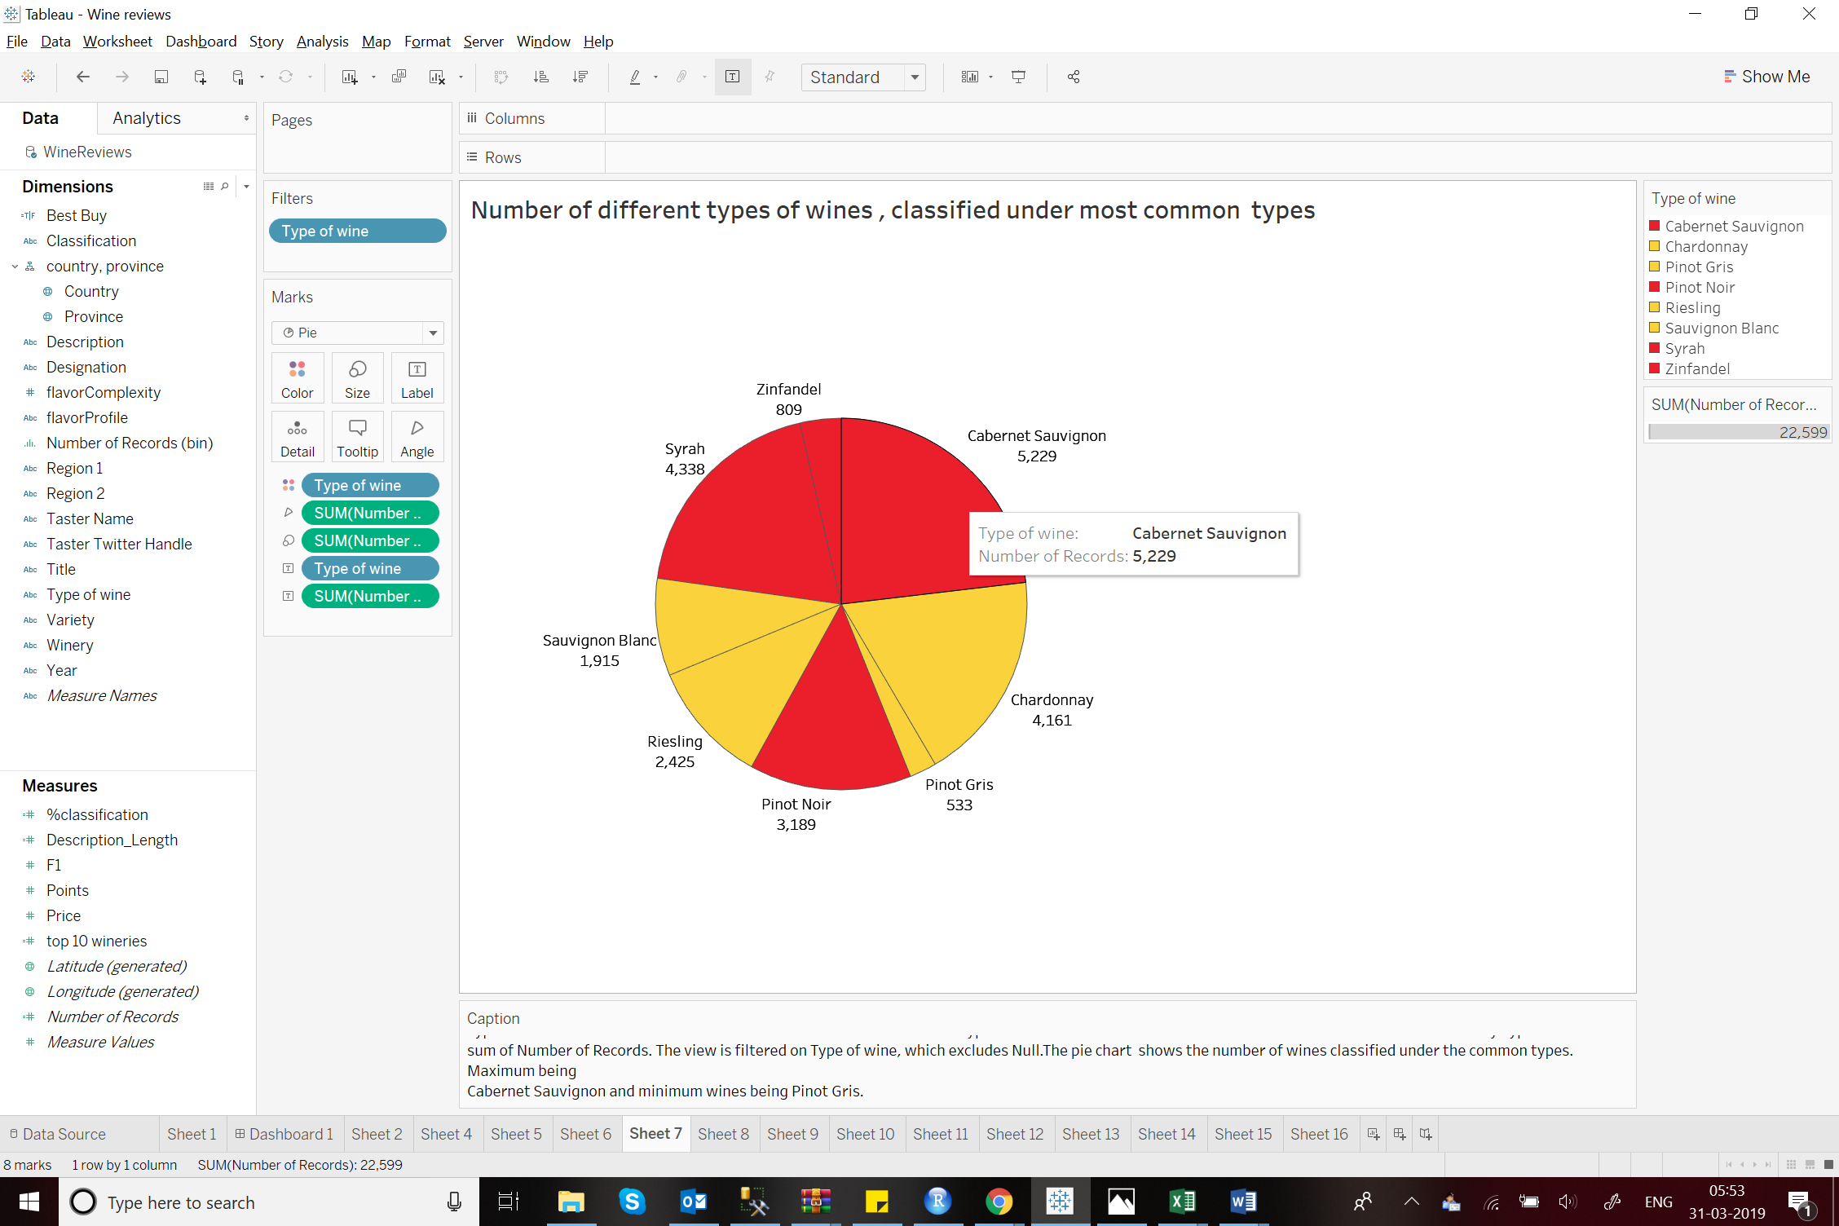

**4.2 Average points of each wine classification:**

The bubble chart gives the average points of these common classified wine records, with their total points.

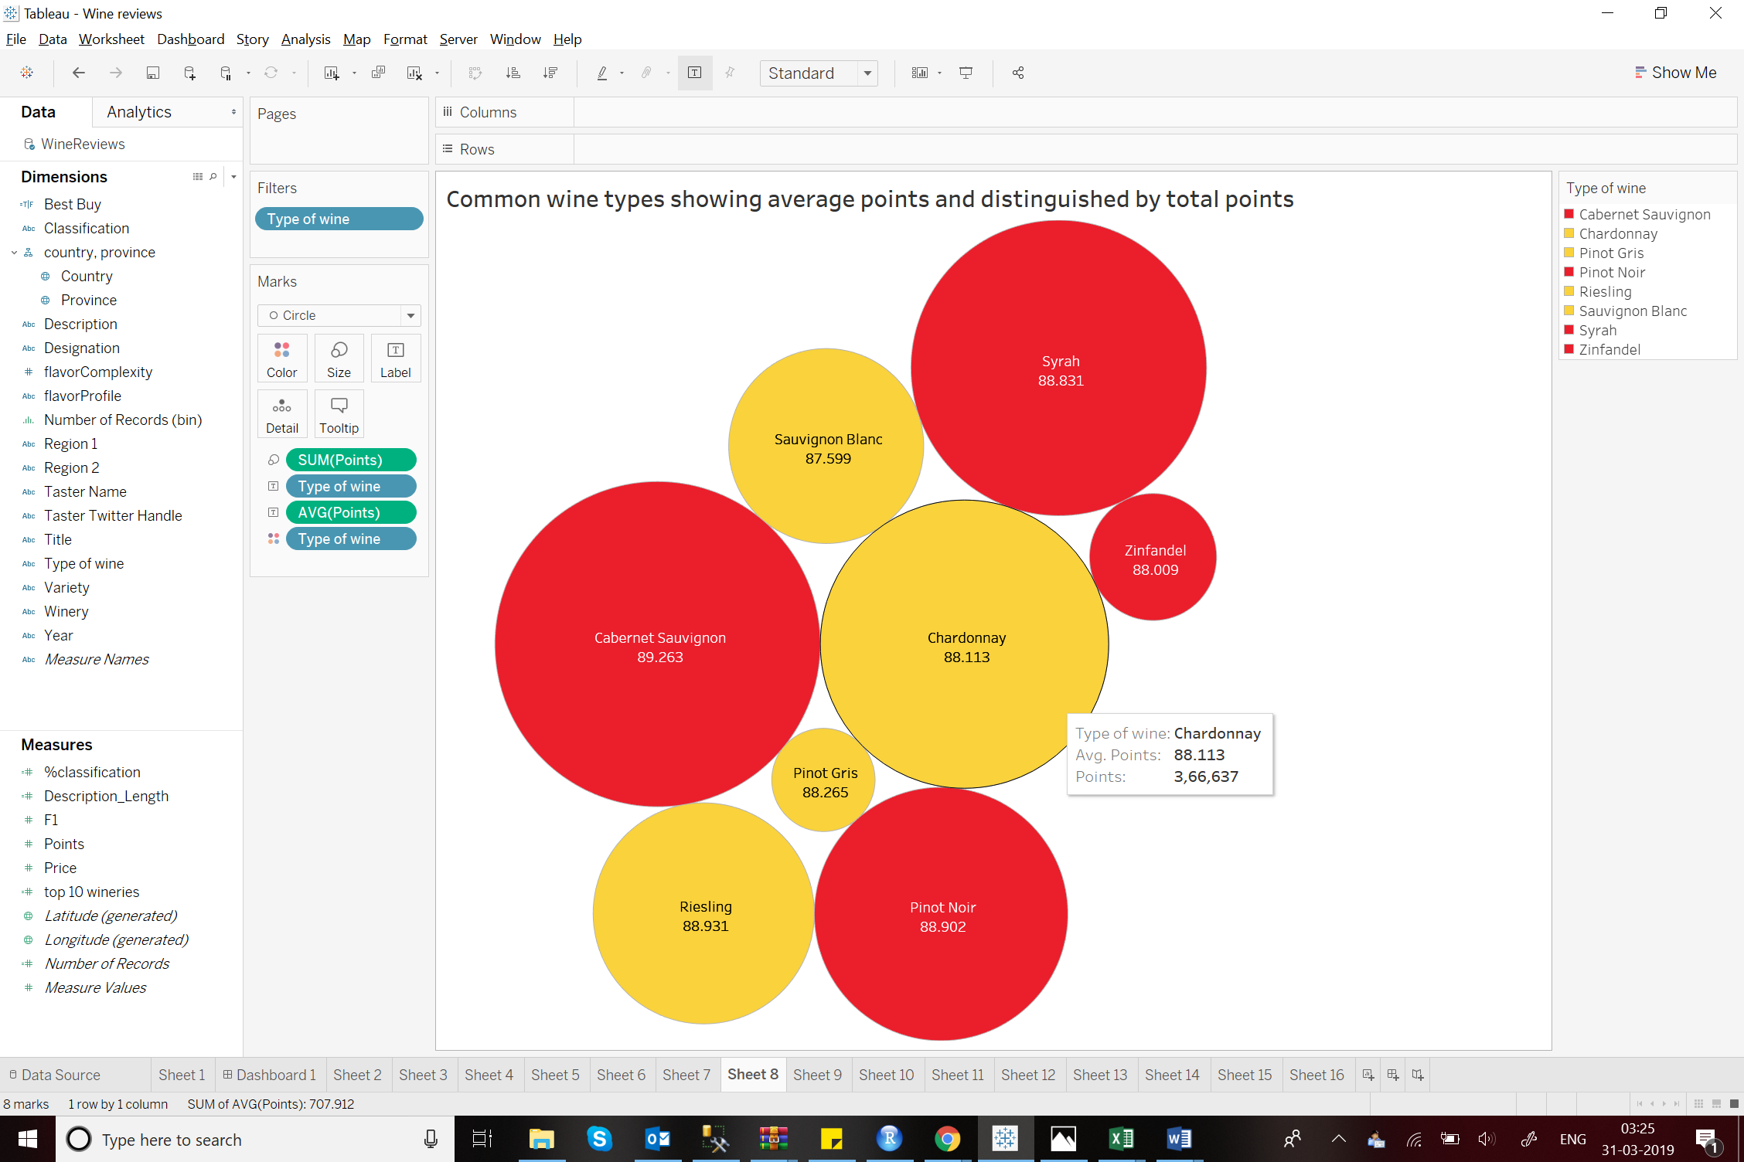

These types are separated into white and red wines using the colours yellow and red respectively.

**Tableau Dashboard:**

To make wine classification based analysis more intuitive, I have created a tableau dashboard.

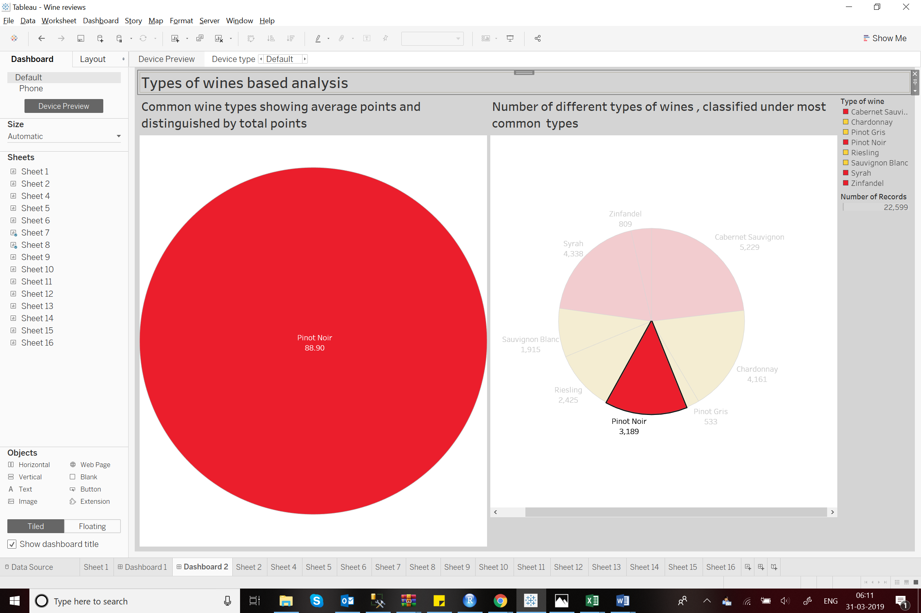

1. **Word Cloud of Rose wine(R):**

The word cloud shows the highest frequency words used for rose wine description. This shows the kind of flavours associated to this wine along with the overall review sentiment. R code is attached.

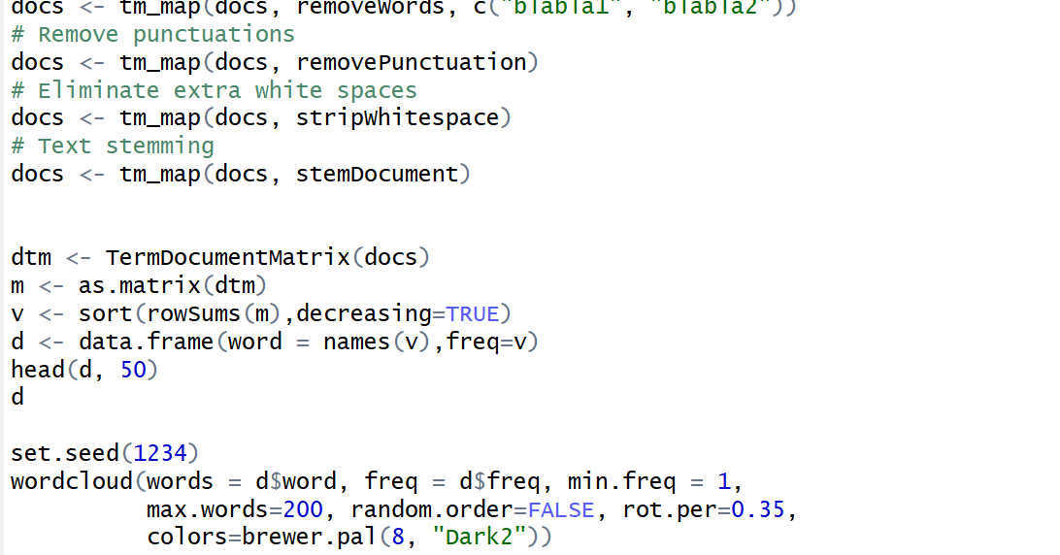

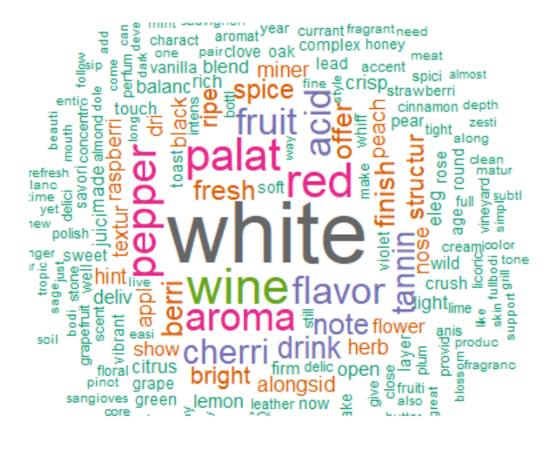

1. **Flavour Profile and Complexity :**

**Data Preparation and Calculation:**

In order to classify the wines into different flavour profiles, I have used R to identify the key words that can be used to segregate the data into different profiles. This column is called **Flavour Profile**. Based on this column I have assigned **Flavour Complexity** which is the number of identified Flavour Profiles. R code is attached.

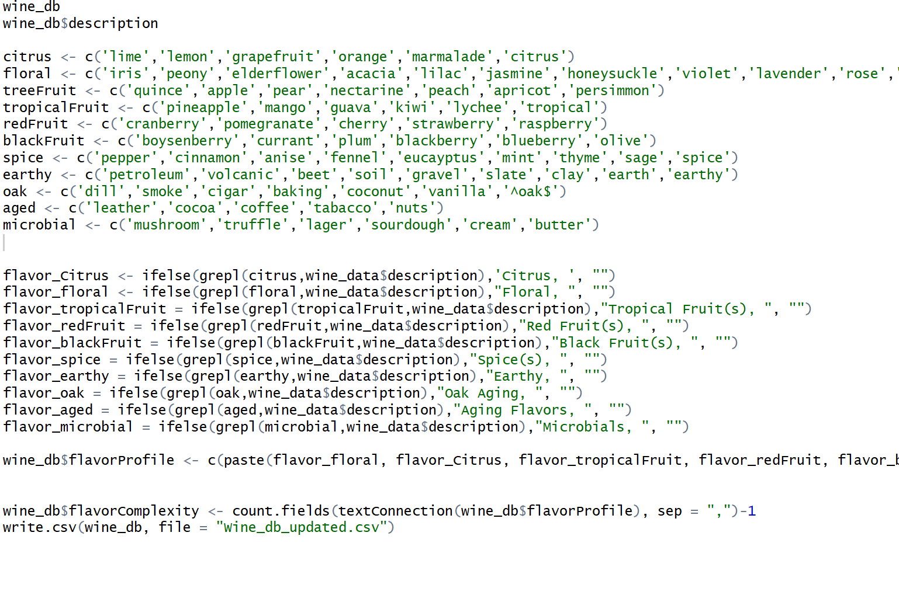

**Visualisations:**

**6.1 The number of wines classified as different flavour profiles:**

This chart gives the different profiles and the number of wines classified as each profile. It also shows the flavour complexity. Maximum wines are classified as Spicy, Citrus, Aging and Tropical Fruits. This chart contains the list starting from a minimum 100 records.

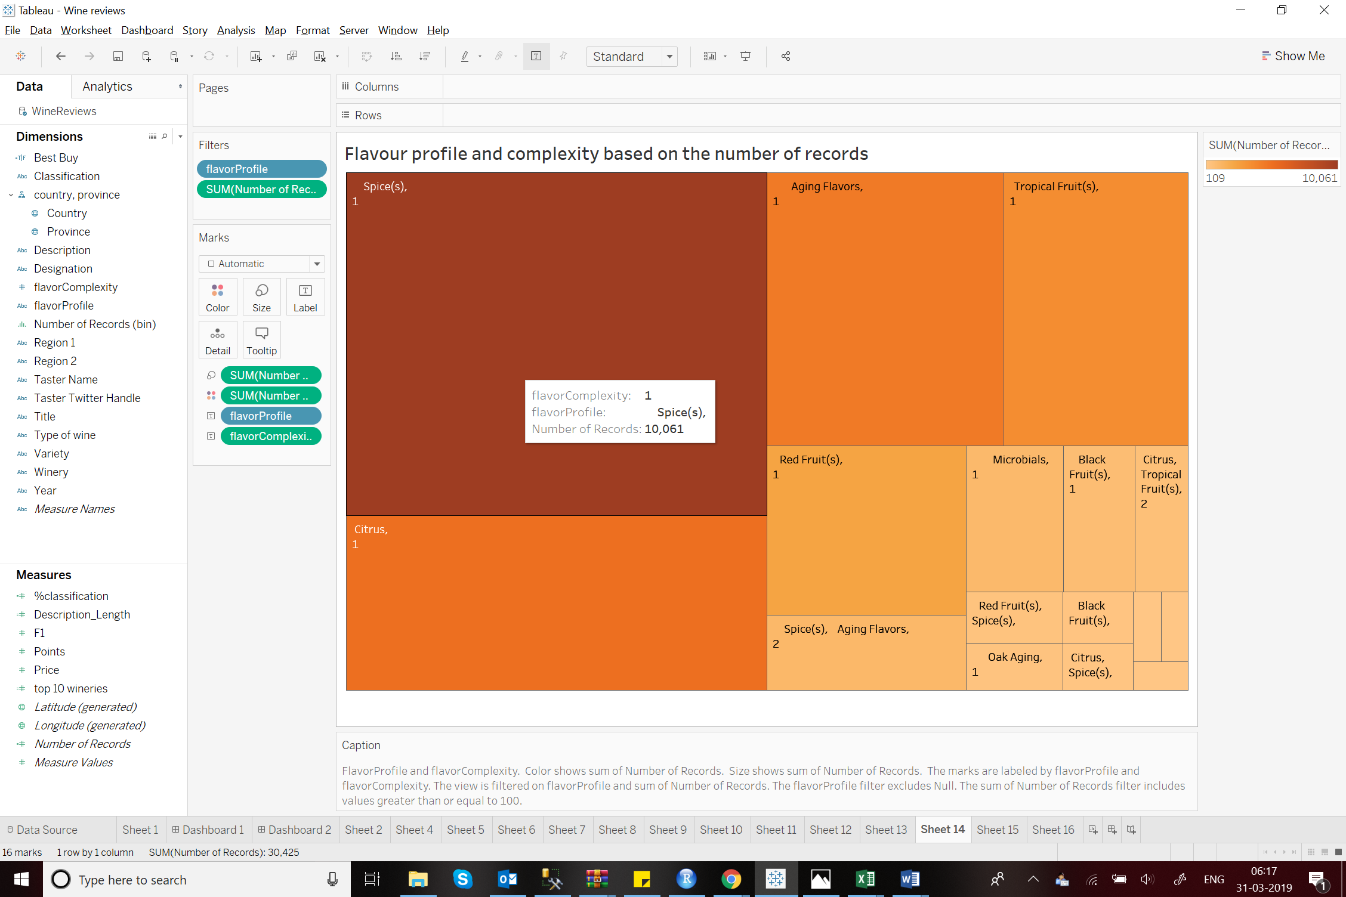

**6.2 Average points given to each identified Flavour profile with the complexity:**

This chart helps identify the popular or favoured flavours and flavour combinations. Although the variation isn’t that drastic, this chart provides interesting insights. Future combinations can be created based on these profile ratings. Flavours with less points may be improvised.

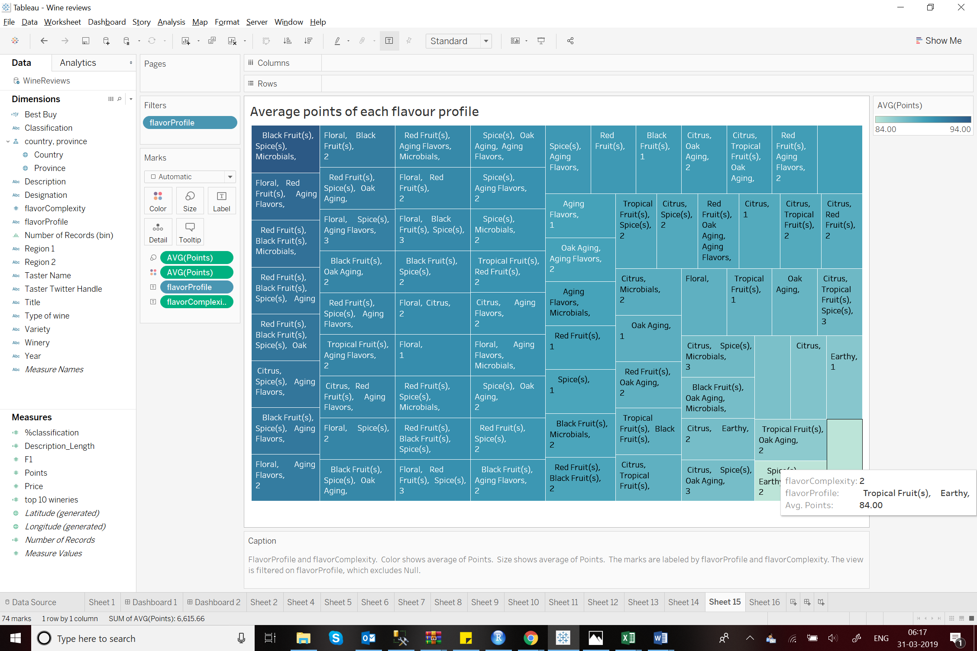

1. **Price range for various Flavour Profiles having different Complexities:**

The plot below shows the price and points of different varieties classified as different Flavour Profiles with complexity 3. This plot gives a good platform for any customer to compare different varieties based on their flavours.

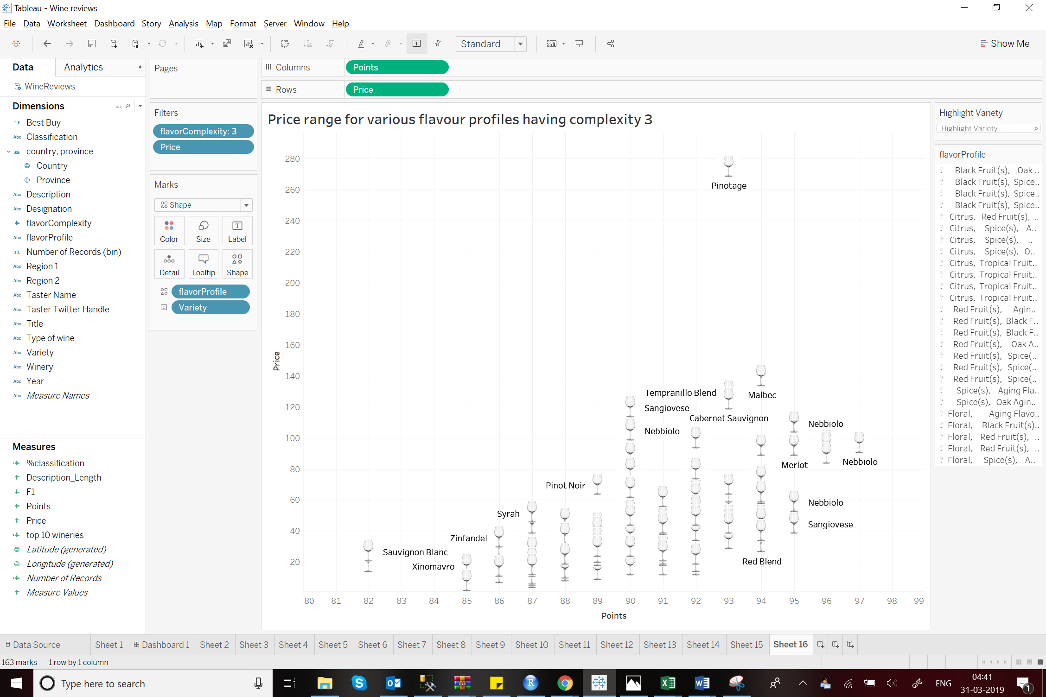

Similarly for complexity 4:

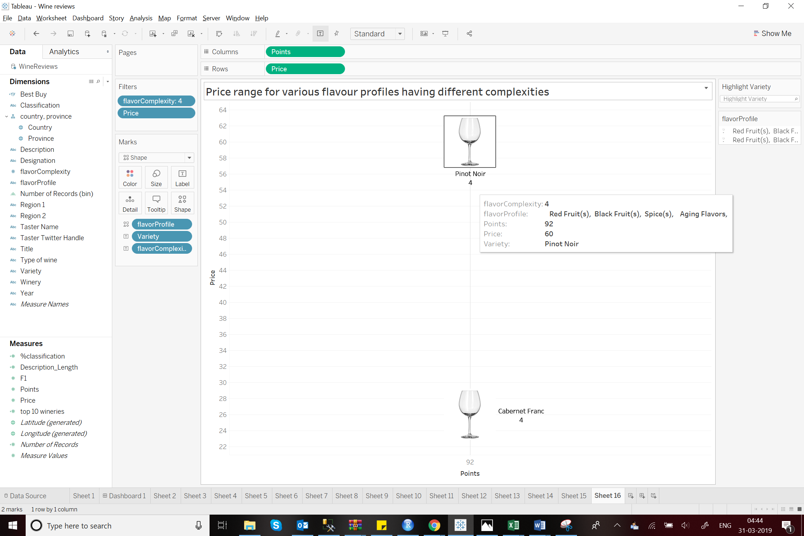

1. **Recommended year for wine consumption:**

**Data Preparation and Calculation:**

To extract the year recommended for wine consumption based on the reviews I used excel formula:

=SUMPRODUCT(MID(0&A2, LARGE(INDEX(ISNUMBER(--MID(A2, ROW(INDIRECT("1:"&LEN(A2))), 1)) * ROW(INDIRECT("1:"&LEN(A2))), 0), ROW(INDIRECT("1:"&LEN(A2))))+1, 1) * 10^ROW(INDIRECT("1:"&LEN(A2)))/10

Using the required data I added a column **Year** to thedataset.

**Visualisation:**

Recommended year for wine consumption(2017-2030):

This animation of bubble chart shows the yearly recommended wines starting from 2017 to 2030.To create this animation I have used the Tableau Pages. Each bubble indicates the suggested variety with its country and total such wine records. These are sorted for varieties with a minimum of 50 wine records for clarity.

2017:

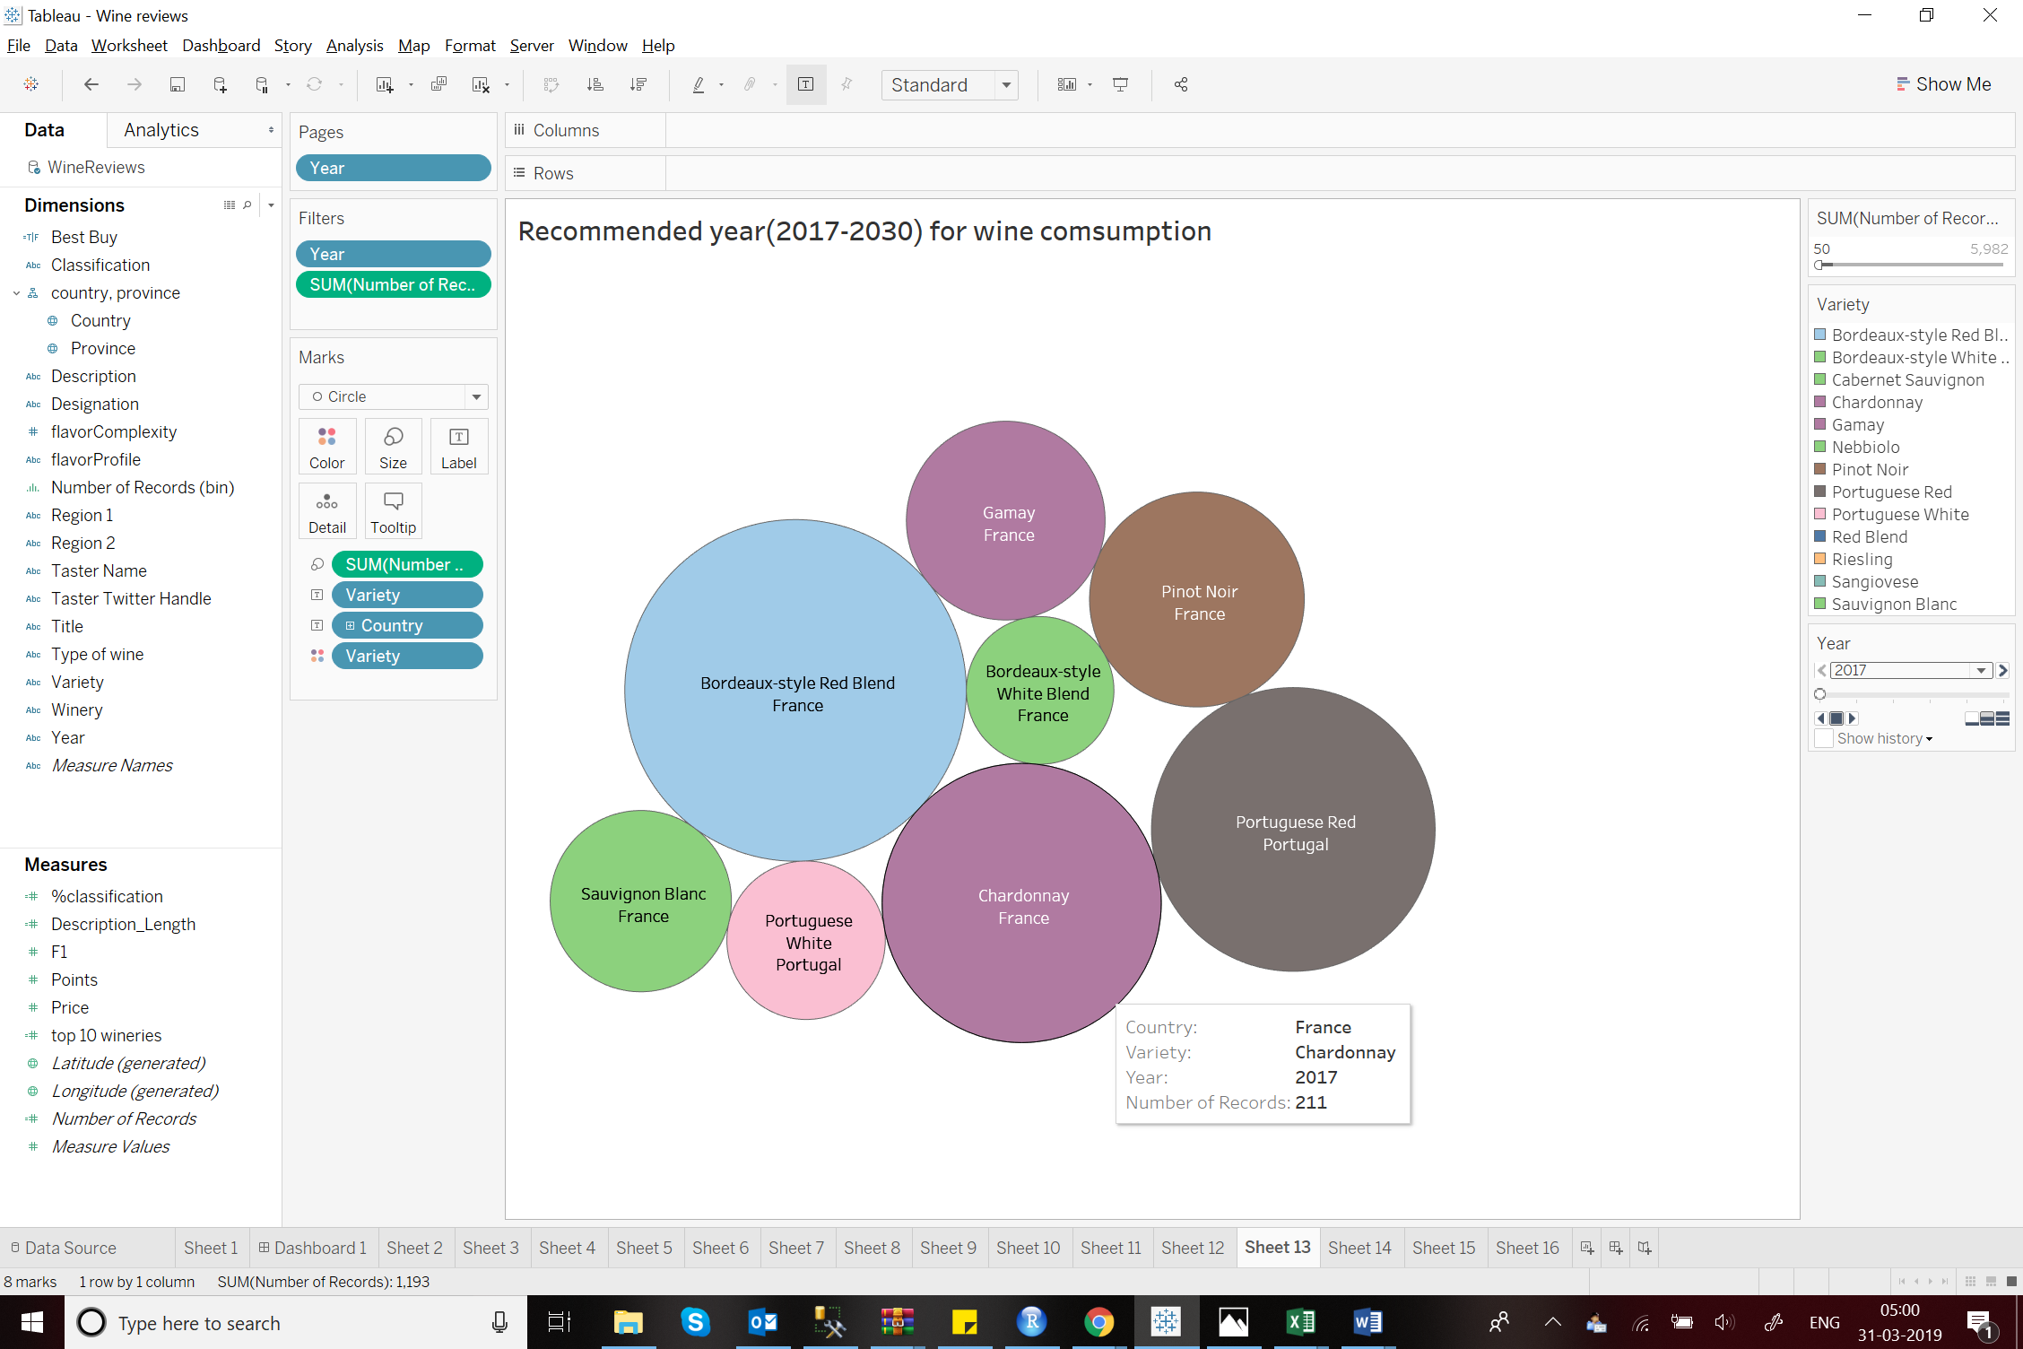

2018:

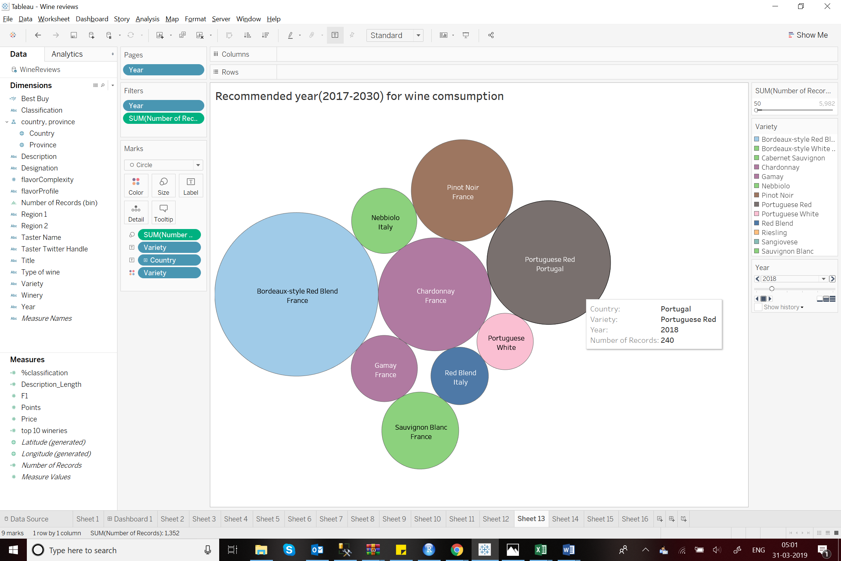

2019:

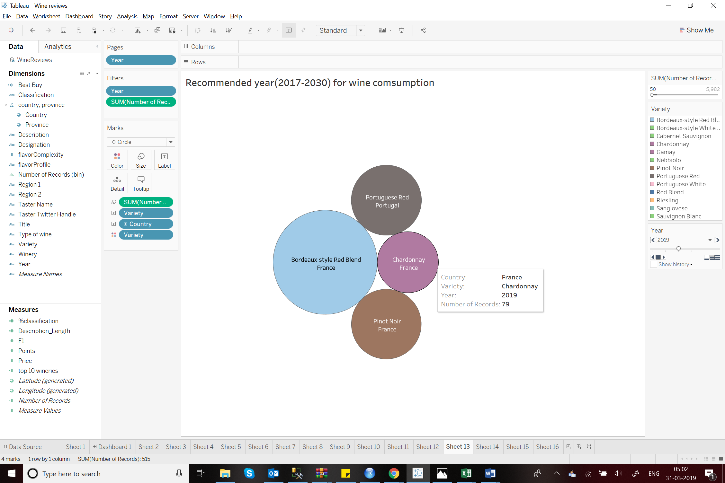

2020:

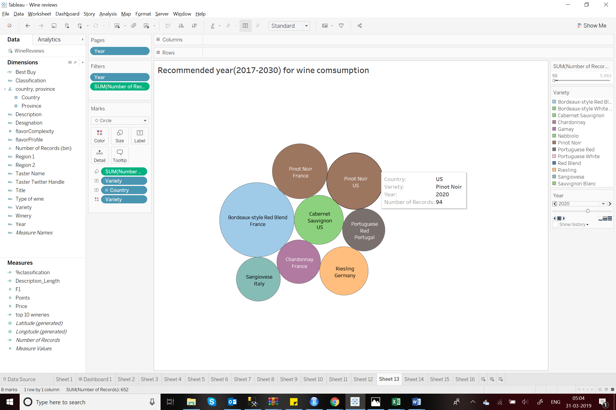

2021:

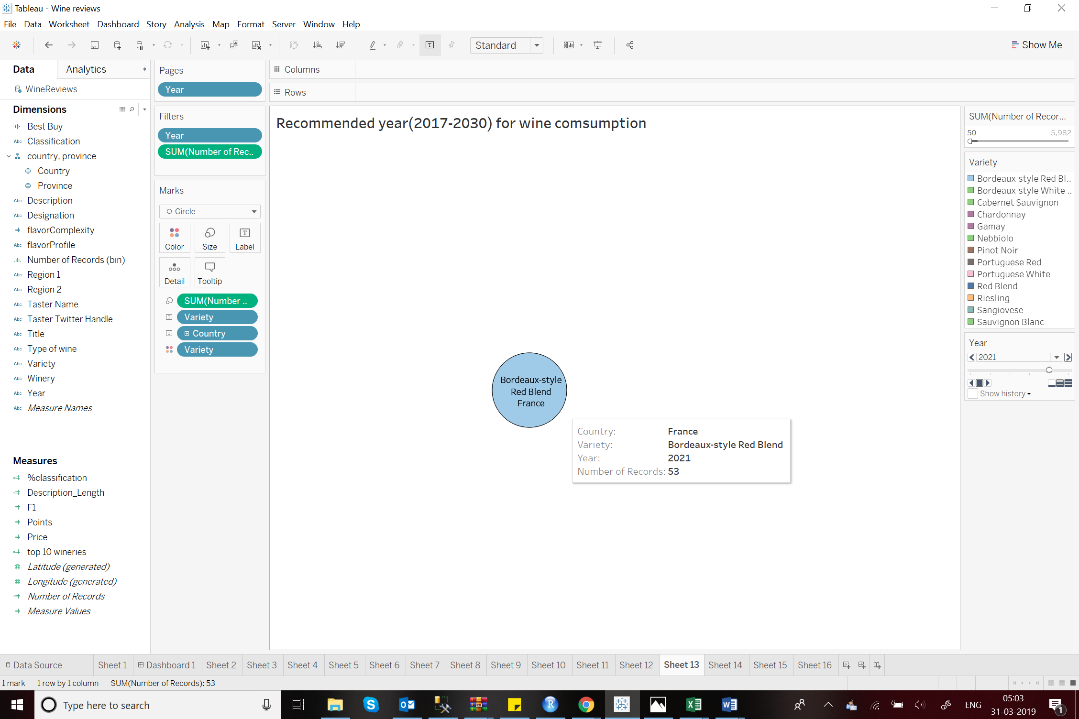

And so on. This plot provides excellent sales insights and future business.

1. **Top 10 wineries of the world based on the review points:**

This bar plot shows the top 10 wineries around the world along with their county and total points scored. 5/10 wineries are from the US. 2 from France and Portugal and 1 from Chile. The Testarossa and Williams Selyem being the top 2, both from the US.

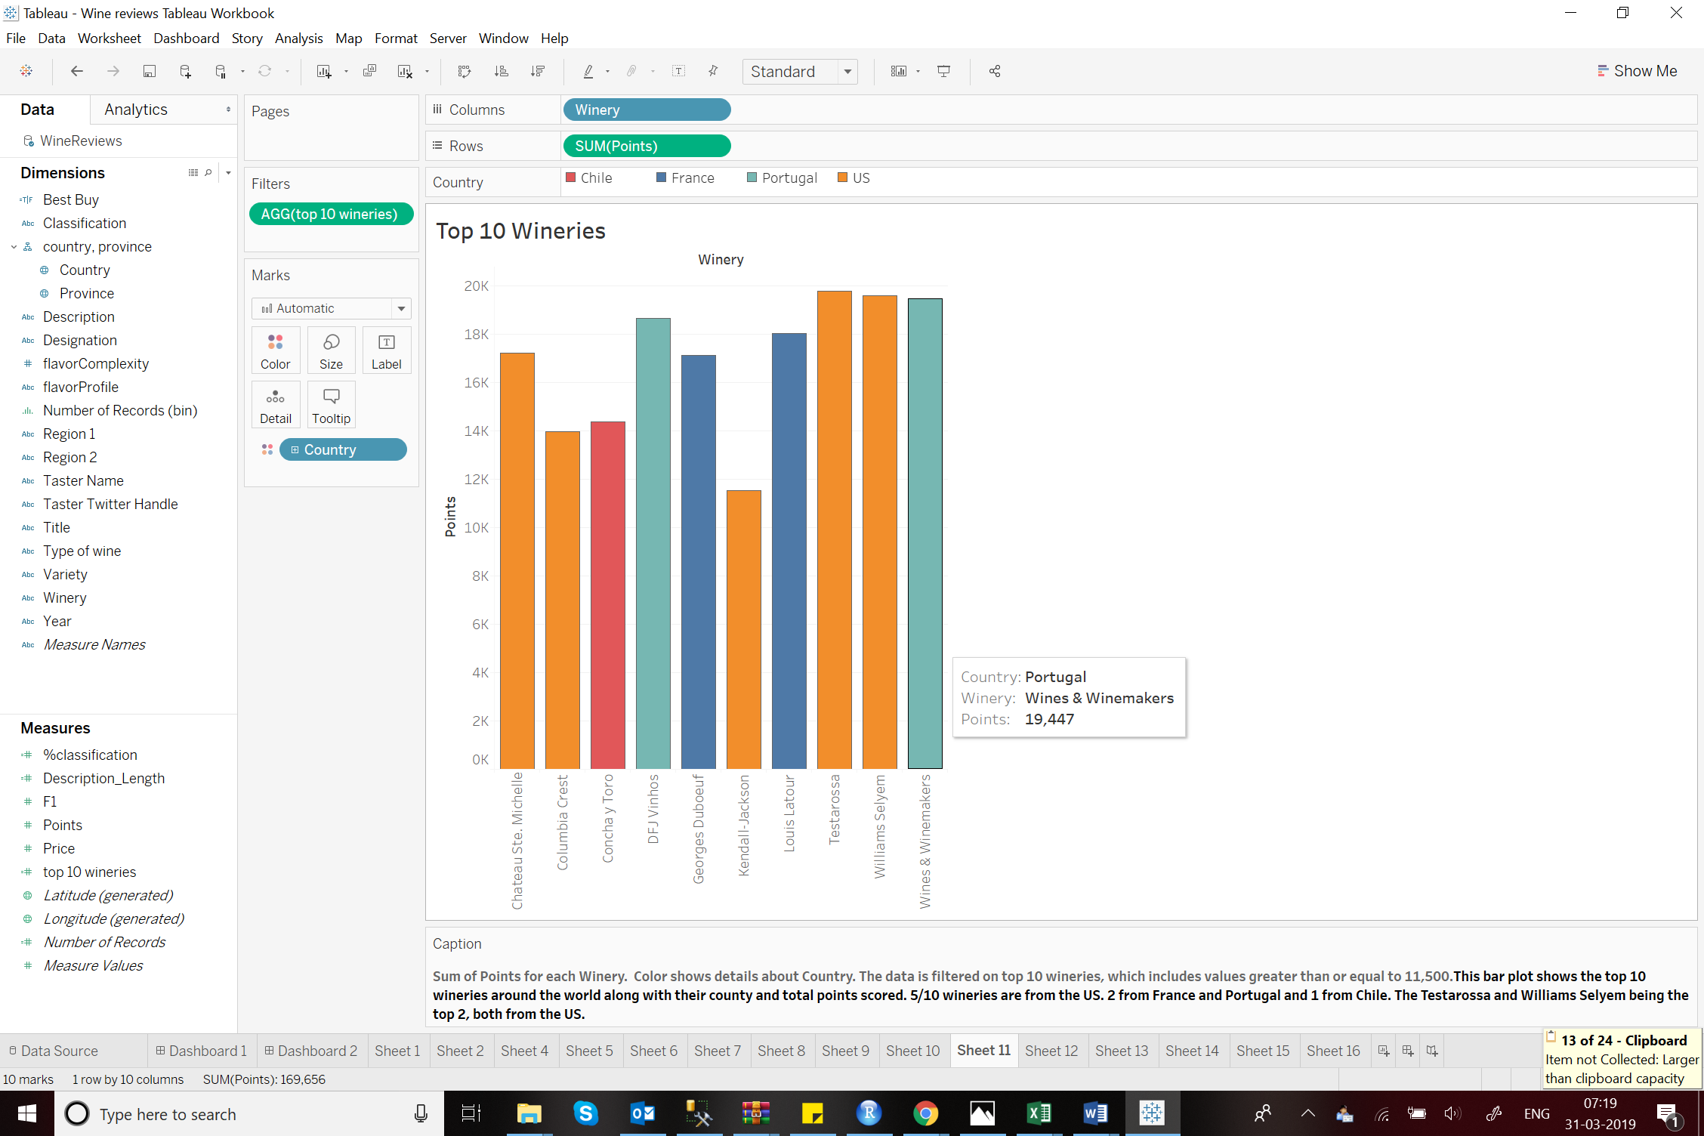

1. **Taster based analysis:**

**10.1 Number of reviews by each taster:**

This bar plot shows the most active taster/wine enthusiast based on the number of reviews given by them. Roger Voss is classified as the most active taster while Christina Pickard being least active giving only 6 reviews.

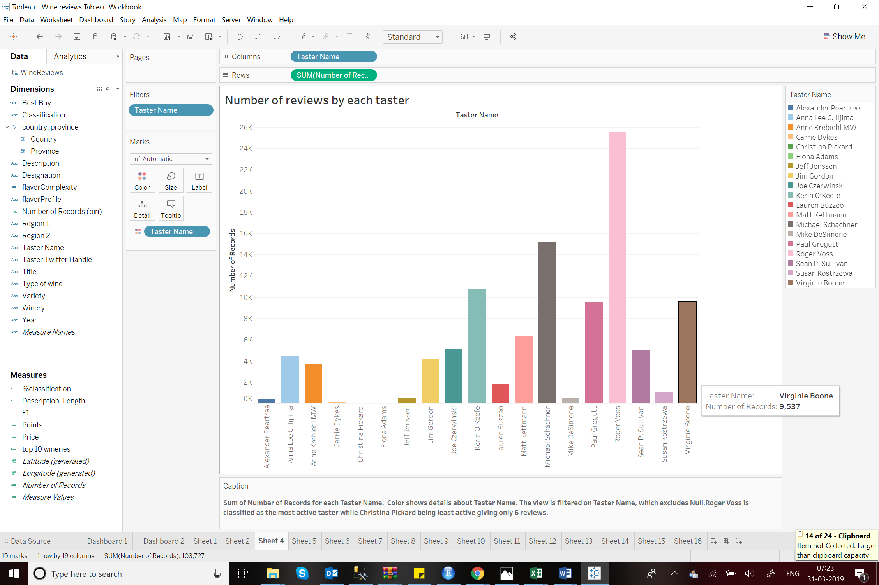

**10.2 Lengths of the Description given by each taster:**

This box plot shows the lengths of descriptions given by each taster. This provides an interesting insight on how detailed is the review provided by these tasters. The least active taster Christina Pickard also has the shortest descriptions.

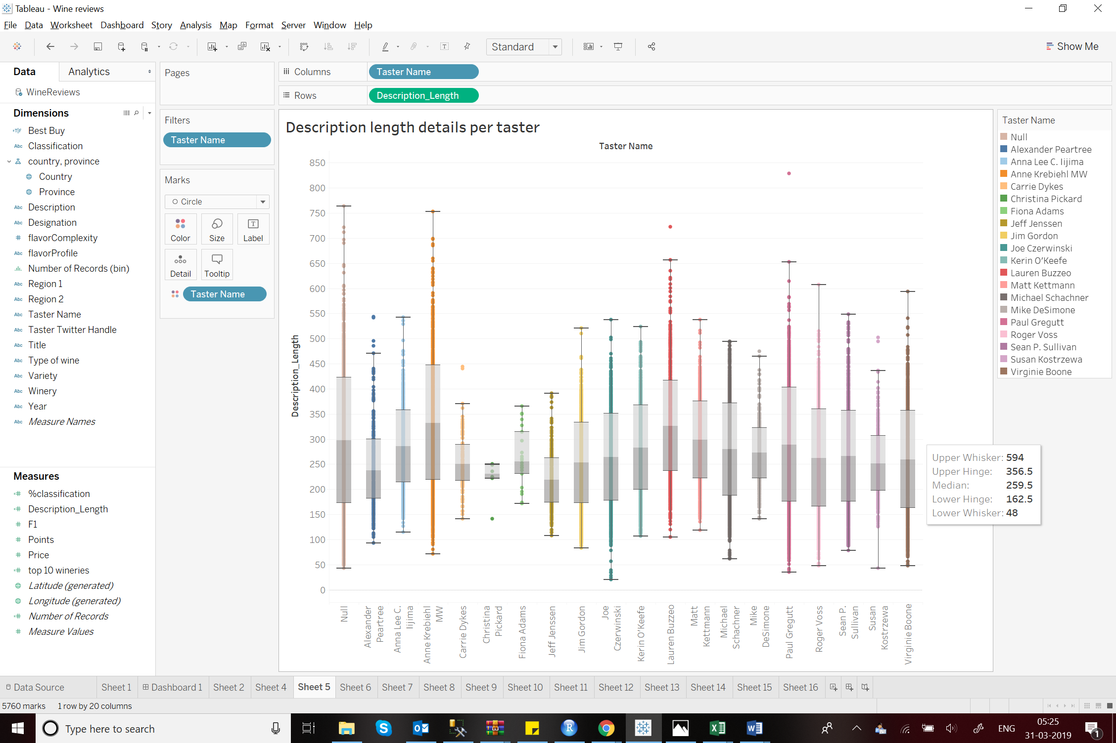

**10.3 Range of points given by each taster:**

This plot shows the distribution of points of each taster. This can be used to gain insights on how lenient or strict these tasters are. One interesting insight shows that there are no points below 80.It is a possibility that reviews giving less than 80 points were not added purposely. Most of the tasters have a similar marking range.

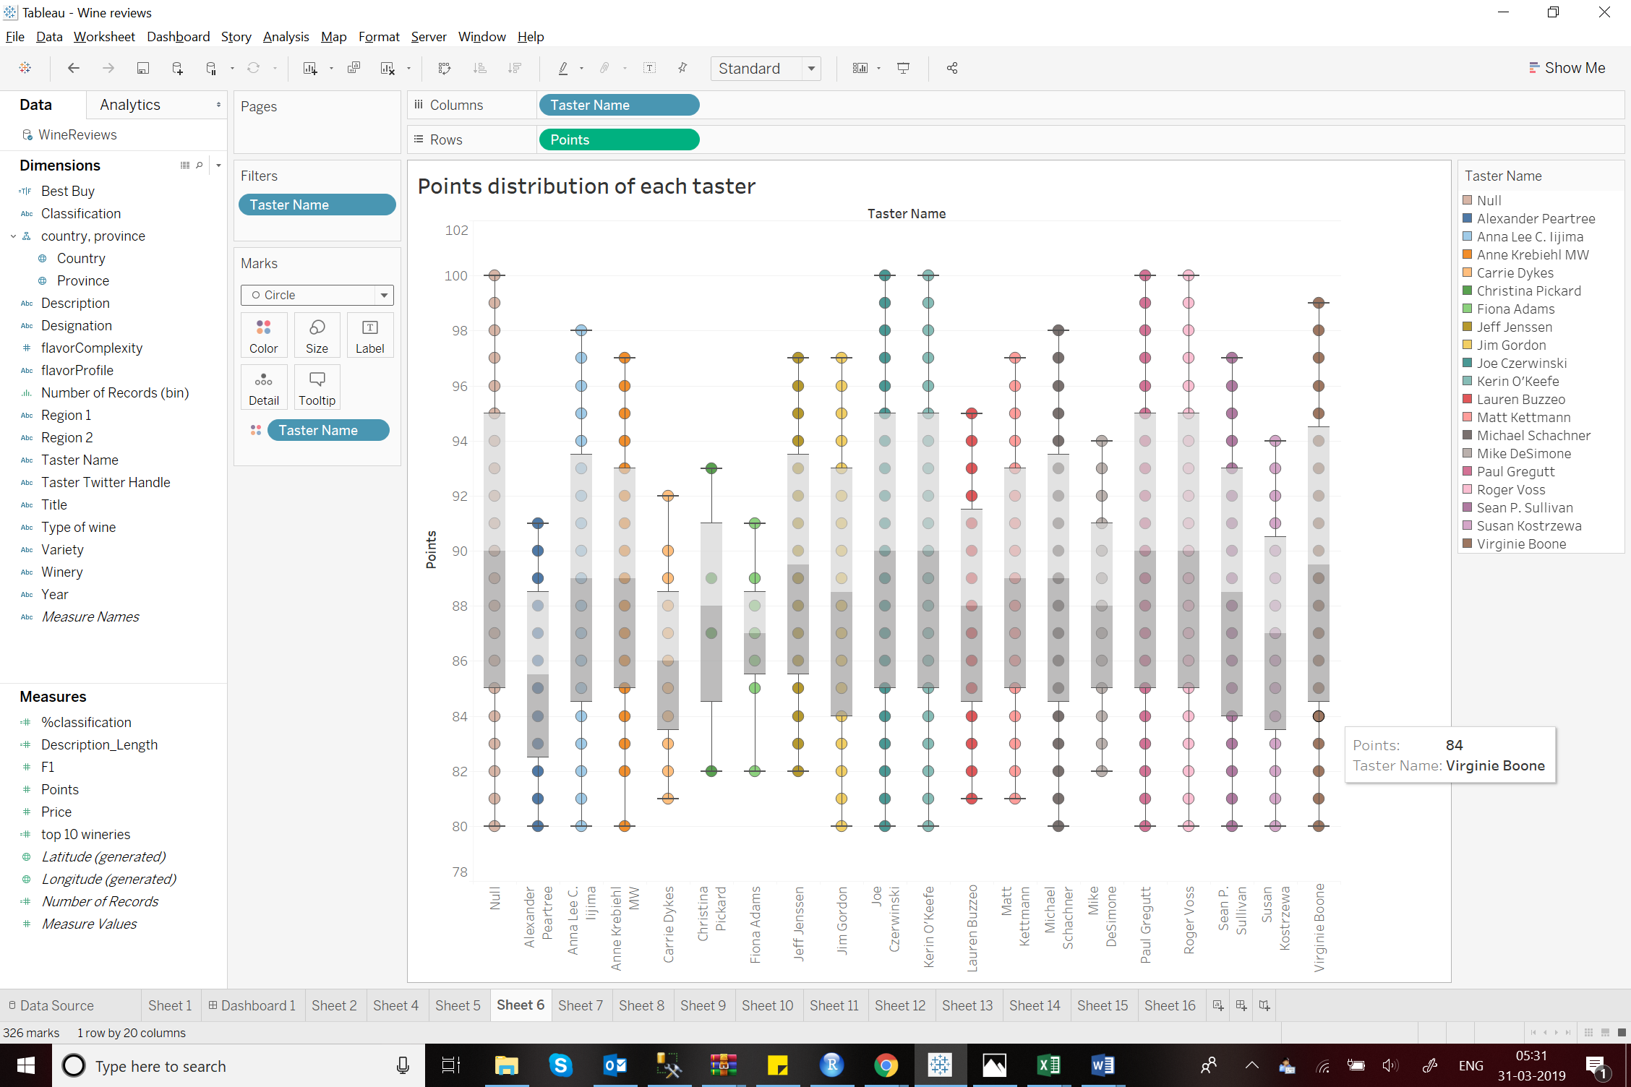

**Tableau Dashboard for Taster Analysis:**

I have created a Tableau dashboard which makes the Taster analysis quicker and easier.

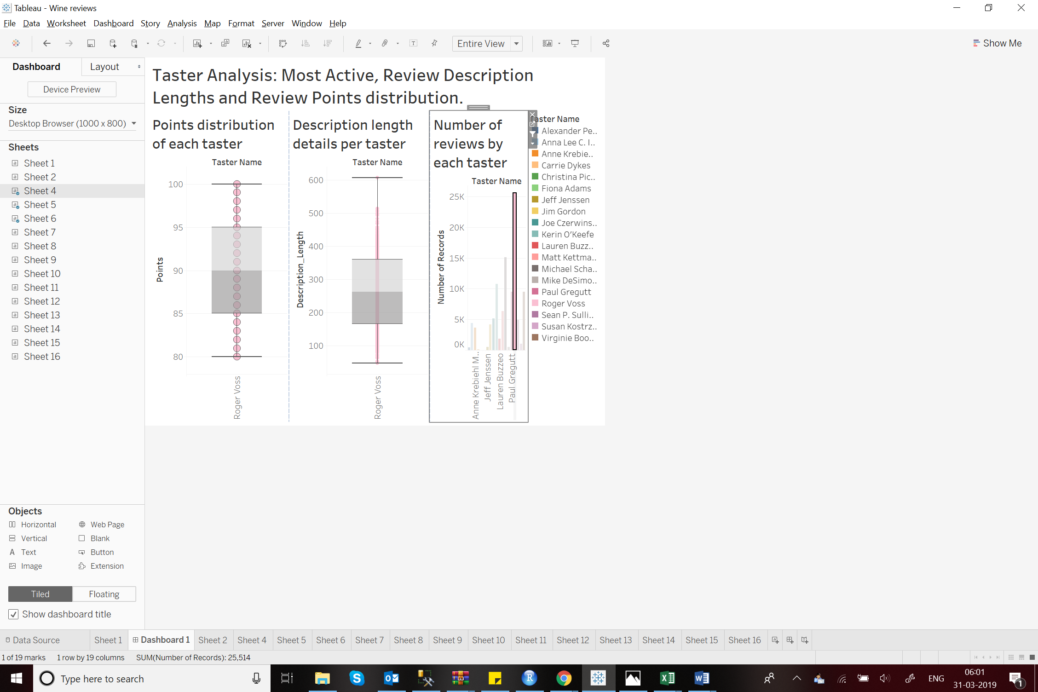

1. **Most reviewed varieties:**

This bar plot shows the 6 most reviewed varieties of wine. Pinot Noir being the highest with more than 13K reviews. Riesling on number 6 having about 5K reviews.

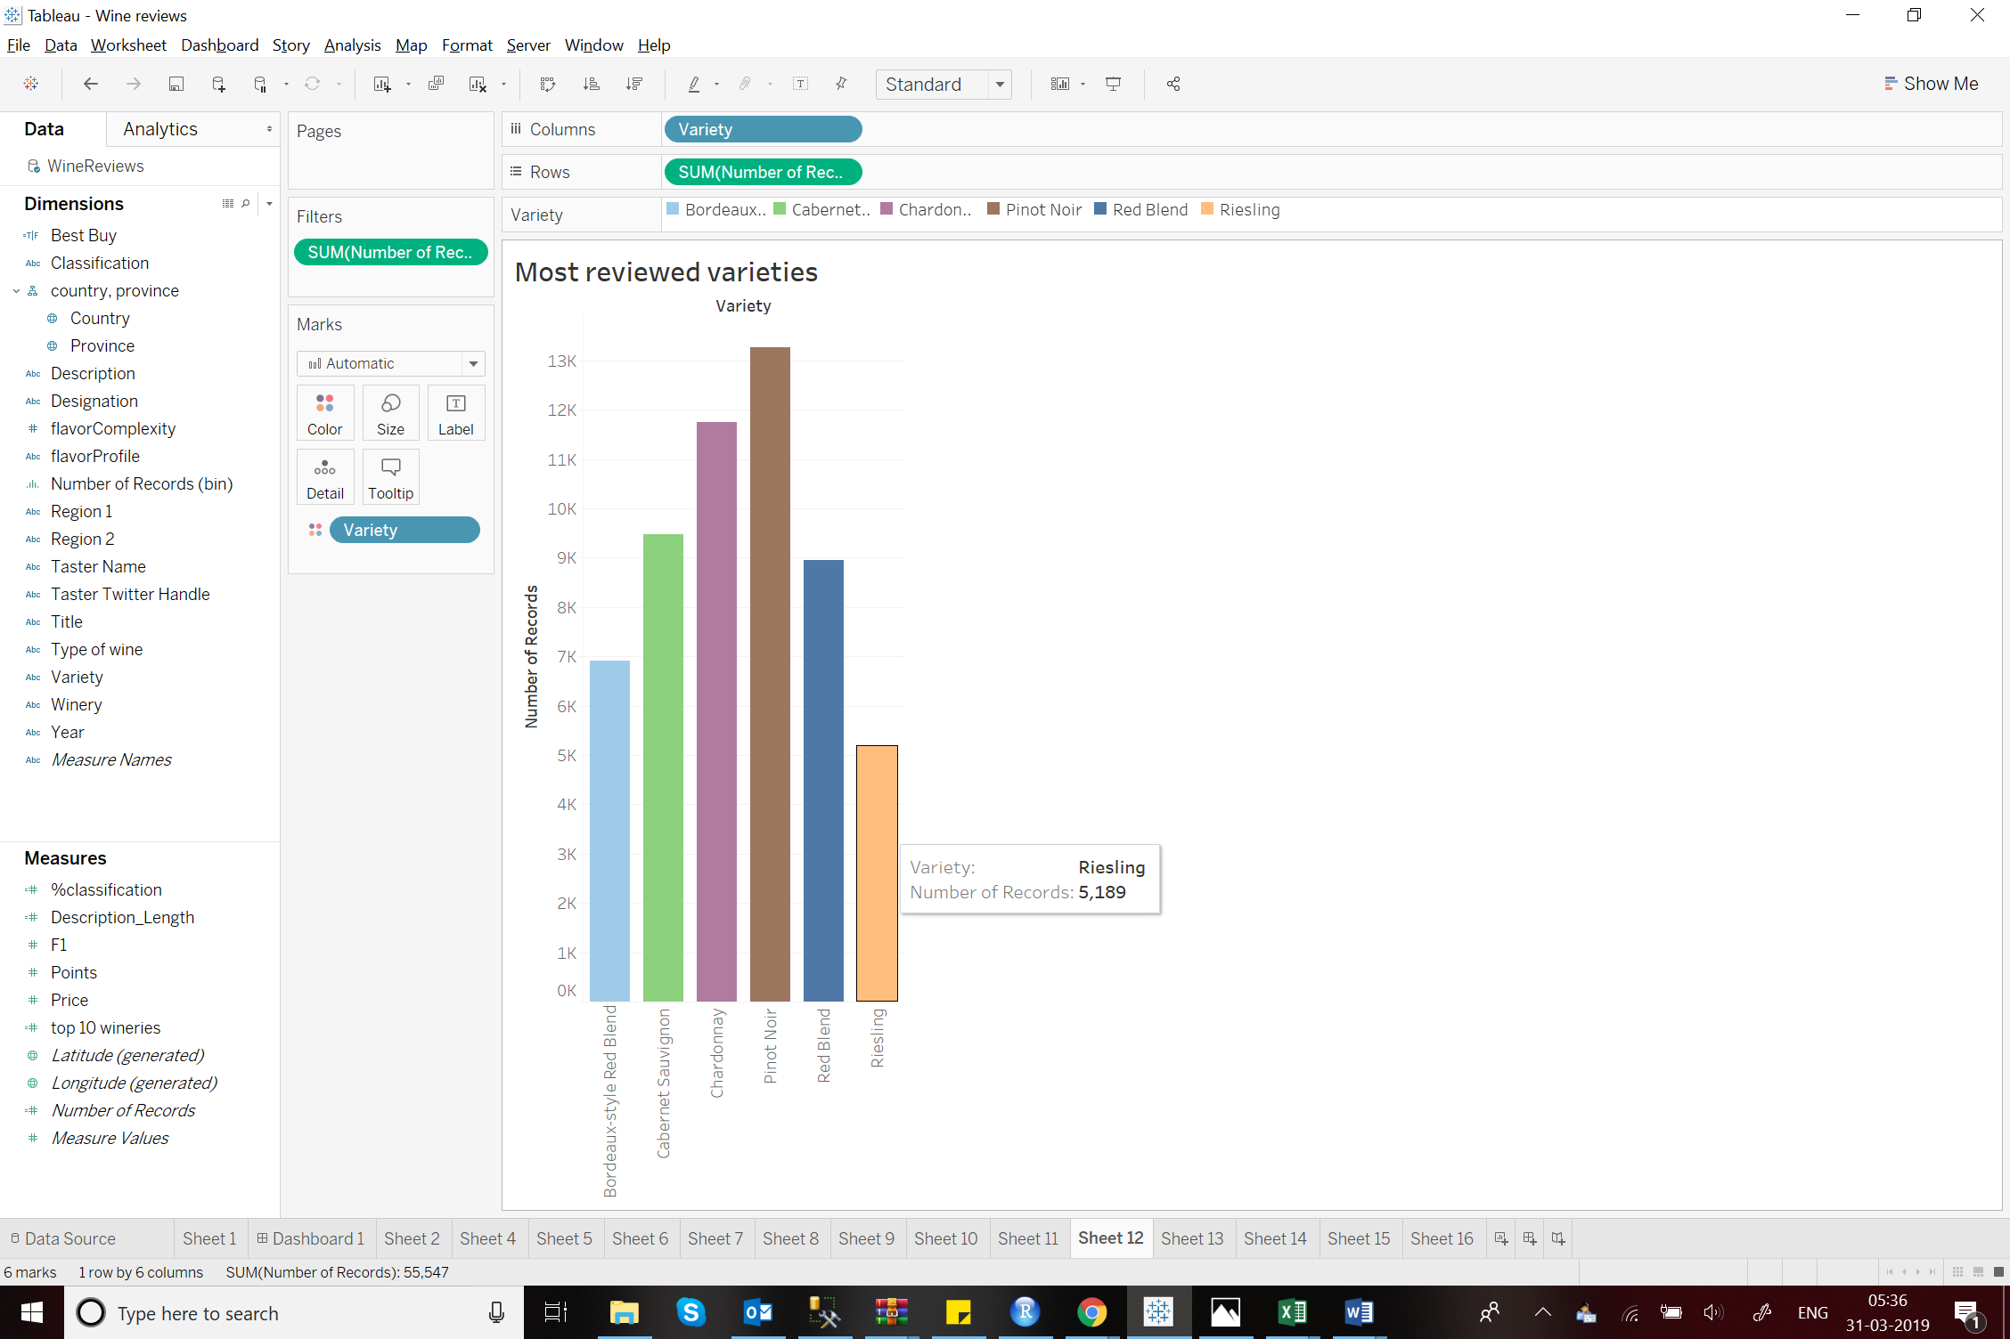

**Summary:**

On the basis of the insights gained by the visualizations, US can be identified as a strong player in the wine industry. Wines can be categorised as Flavours, Flavour Complexity, Types etc. Each Flavour is unique and has its own niche. The wine market is very vast having good wines in each price range. The visualizations successfully address the initial questions and also provide additional insights for the same.